**ProdduturuAneeshPavanProjectDescriptionCS6001**

**Aneesh Pavan Prodduturu**

I'd like to split my project into two parts. The first segment includes a rural viewpoint with ocean waves, a long mountain, a viewpoint, a seashore, a bonfire, soccer balls, and mocap biped characters. The second section includes an urban view with ocean waves, skyscrapers, a viewpoint, and a row of flags. I used a moving sphere with light as the sun in between to create sunrise and sunset effects depending on the frame. To make the project more realistic and creative, I added several light and camera nodes. To make the animation as smooth as possible, I included a cache node wherever possible.

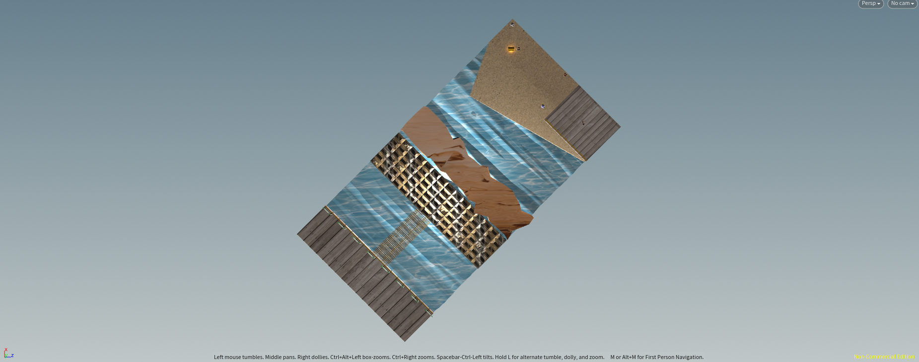

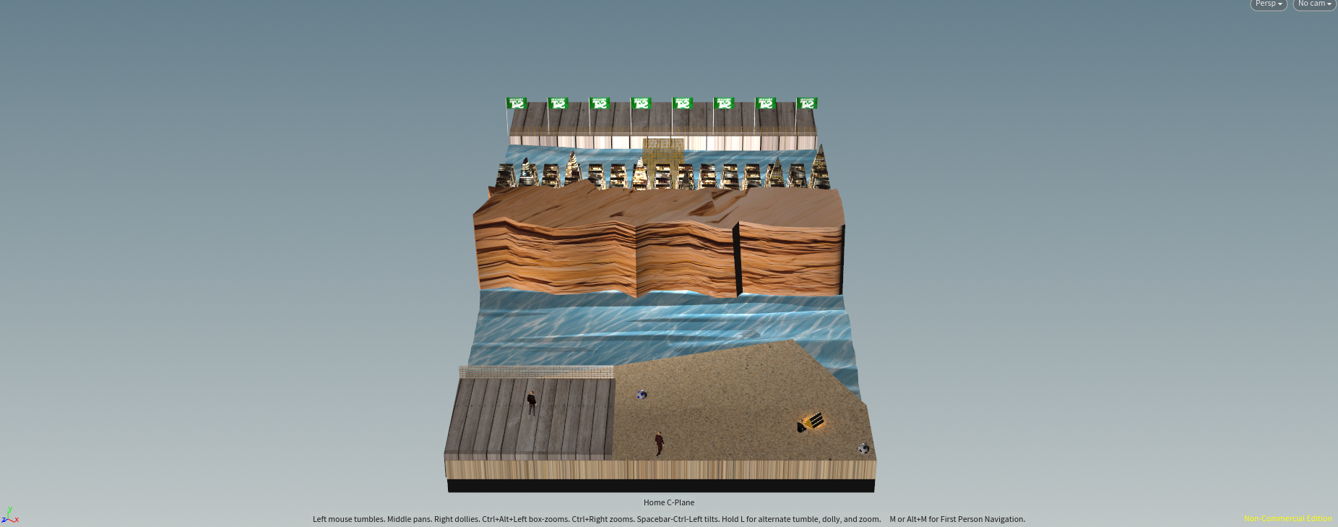

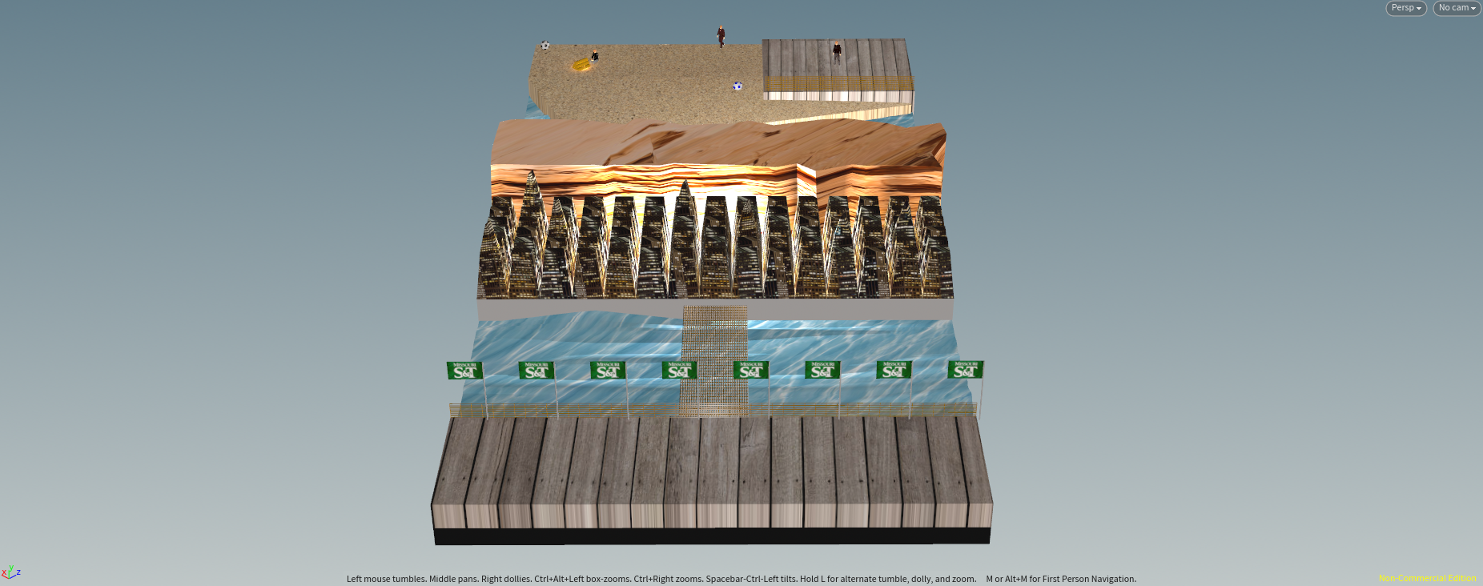

I focused primarily on applying the new skills learned in this class in a variety of ways. To make ocean waves, for example, I used the Ocean Evaluate, Ocean Spectrum, and Ocean Waves nodes. Arealight and pointlight were used in various locations, and shadows were enabled. I used cameras to show different perspectives, and I created smoke for a bonfire using PyroFX's sparse billowy smoke. and Vellum nodes for the flag row in the urban viewpoint.

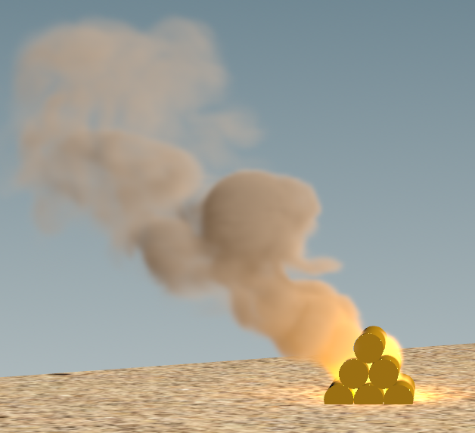

To begin, I made a common base with a grid, polyextrude, and color nodes to place both viewpoints on opposite sides of the base. Then I proceeded by creating common ocean waves, displaying the same waves on both sides, and reducing the load on my system. For ocean waves, I used uvquickshade to create a grid in the ZX plane and then added an image, followed by an ocean evaluate node, with the first input being an ocean grid connected to uvquickshade and the second input being an ocean spectrum node. I added the ocean evaluate node again, this time connecting the output of the previously added ocean evaluate node to the first input of the newly added ocean evaluate node. The second input is a new node called ocean waves, which aids in the generation of ocean waves. I was able to get the ideal waves for my project by adjusting the ocean spectrum and ocean wave nodes.

h

For the rural viewpoint, I simply used a transform node to adjust it, a bend node to bend the sand and make it look more like a seashore, and a uvquickshade node to add a picture. To set the stage for the view, I used a grid, polyextrude, uvquickshade, and a UV texture node for the rural viewpoint, and for the railing, I added another grid, polyextrude, and color node and adjusted the distance and inset in polyextrude to make it look like a railing. I added two platonic solid nodes with colour nodes, chose a soccer ball as the solid type, and placed them on the sand. For the bonfire, I created a geometry node with six tubes and merged them with a merge node. I changed the translate to make it look like a stack of wood. Rather than using a PyroFX bonfire, I created smoke for the bonfire using light and PyroFX sparse billowy smoke. To make the surface of the long mountain uneven, I added a grid connected to a mountain node and connected polyextrude and uvquickshade. I added a few mocap biped characters as audience members. This completes the rural viewpoint of the project.

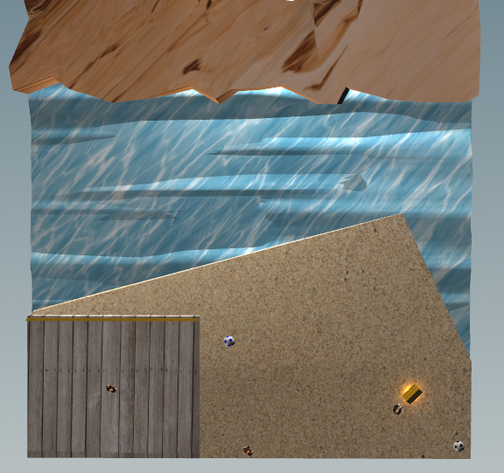

I designed skyscrapers, a bridge, a railing, a base, and a row of flags from an urban perspective. I used a grid, a polyextrude, another polyextrude, and an uvquickshade to create skyscrapers. To make them look like boxed buildings, I divided them into individual components and increased the distance between them. I used more transform nodes to build the foundation for skyscrapers and urban viewpoints. I used an adjusted version of the railing from the rural viewpoint for the railing. I added a grid, polyextrude, and color to the bridge and followed the same steps as the railing but in a different orientation and placement. I made another geometry flag with vellum and the copytopoints node for flags. I began with a grid, polyextrude, vellum constraint, and vellum solver nodes to create the flag's movement, pinpoints, and animation, and then added a tube to create the flag's rod. I combine these two, add another grid node, and a copytopoints node to multiply the flags and place them on the target grid. This completes the urban viewpoint of the project.

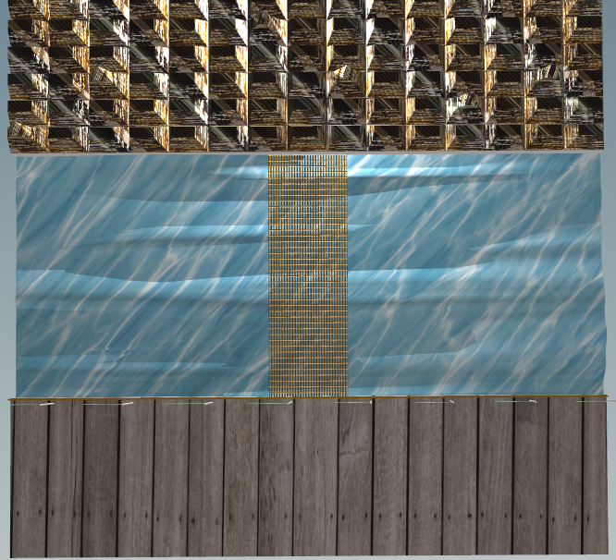

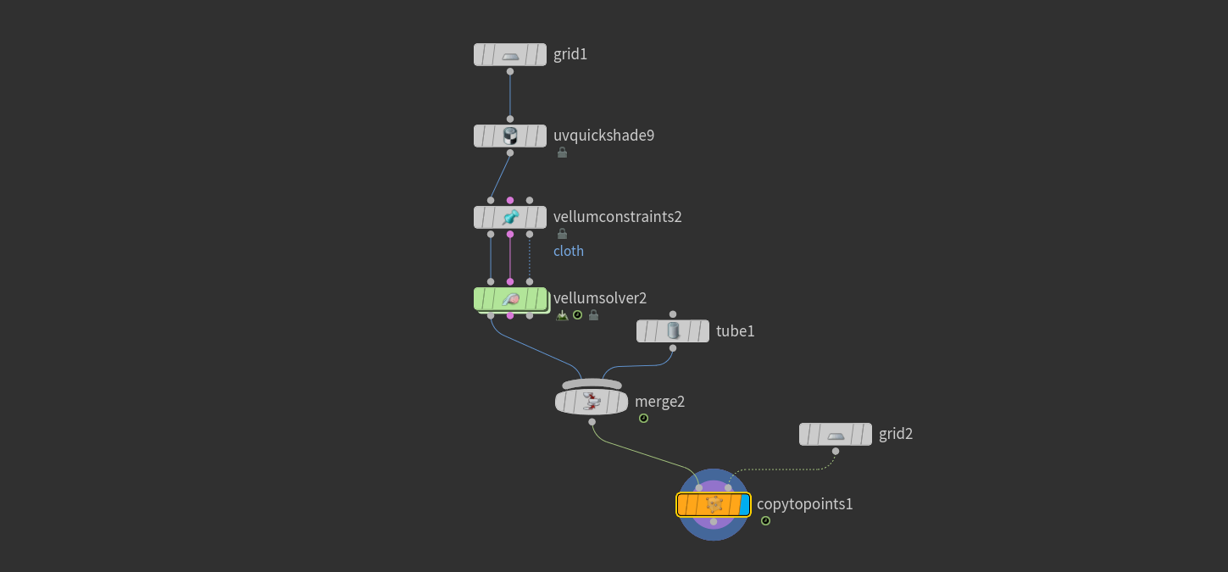

I used a sphere geometry connected with a pointlight to make it look like a sun, and this $F expression is used in the translate y-axis "($F - 1) / 50 * 15 + 0" to slowly move up the sun and light.

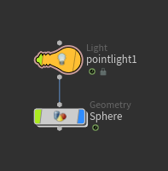

As I previously mentioned, I used cameras with animation to make the project feel more like a story mode. I began by capturing various perspectives with multiple cameras and applying $F animation to the translate axes to make the camera move when the frame was played. After I had set all of the camera animations to make it more interesting, I used a switcher node and connected all of the cameras into it, and set a $F expression in the switch camera section so that it traverses through each camera after some time, which is "floor($F/26.6)" which allows each camera some time and can be automatically traversed from one camera to another from the switcher node itself.

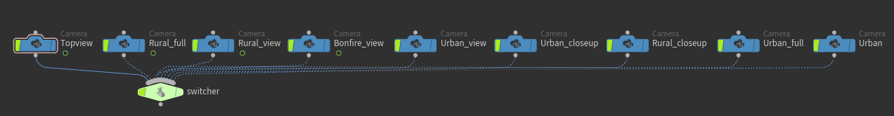

Here is a screenshot of the parameters pane’s geometry level, which consists of both viewpoints.

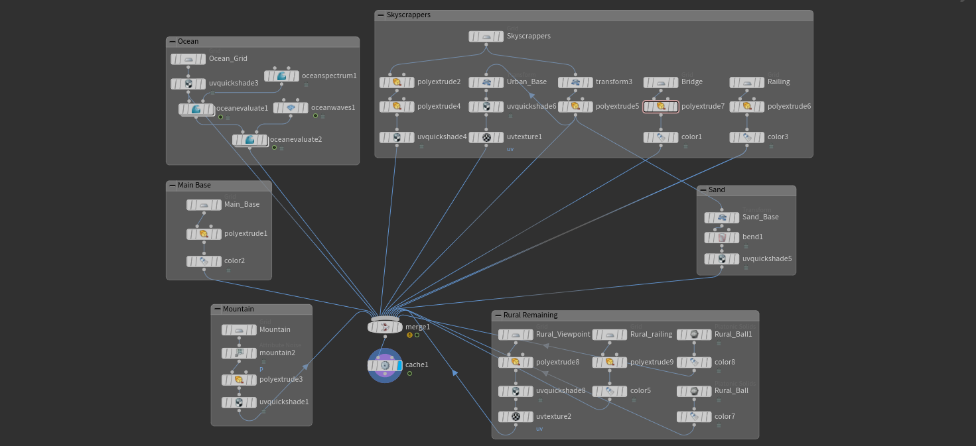

Here is a screenshot of the parameters pane’s object level, which consists of lights, cameras, a bonfire, and other remaining features included in my project.

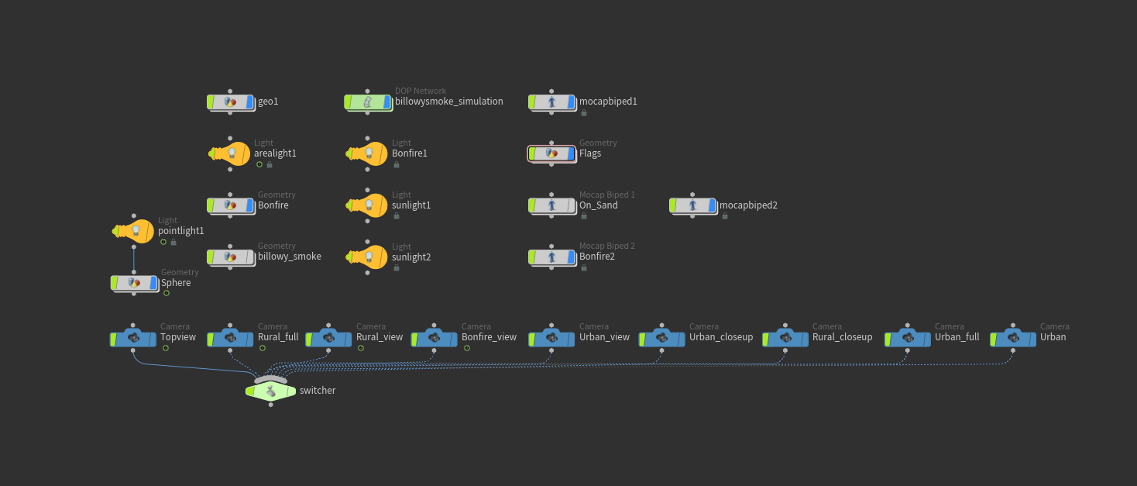

This concludes my project, which included almost everything I learned in this course, including ocean waves, pyroFX, vellum, lights, cameras, and much more.